Zachery Francis
CISC 3140
2/5/2026
Brooklyn College

Homework 1

- Create a four-function (basic arithmetic) calculator.
Constraints: Arguments are either integer or floating point.

https://tinyurl.com/36scaxmp

#lang racket

(define (Start)
(display "At any time type 'Abort' to exit program... or 'Reset' to start over!")
(newline)

(display "Constraint: Integer or Floating Point only...")
(newline)

;; abort function in progress...

(display "Enter a number: ")
(define x1 (read))
(newline)

(cond
[(eq? x1 'Reset) (Start)]
[(eq? x1 'Abort) (exit)])

(define (system_loop)
(display "Enter an arithmetic function/operation (+ - * /): ")
(define operation (read))
(newline)

(cond
[(eq? operation 'Reset) (Start)]
[(eq? operation 'Abort) (exit)])

(define raw_operation
(cond
[(eq? operation '+) +]
[(eq? operation '-) -]
[(eq? operation '*) *]
[(eq? operation '/) /]
[else (error "Error: Unknown Operation")]))

(display "Enter a number: ")
(define x2 (read))
(newline)

(cond
[(eq? x2 'Reset) (Start)]
[(eq? x2 'Abort) (exit)])

(define ans (raw_operation x1 x2))
(display "Answer: ")
(display ans)
(newline)

(set! x1 ans)

(system_loop)
)

(system_loop))

(Start)

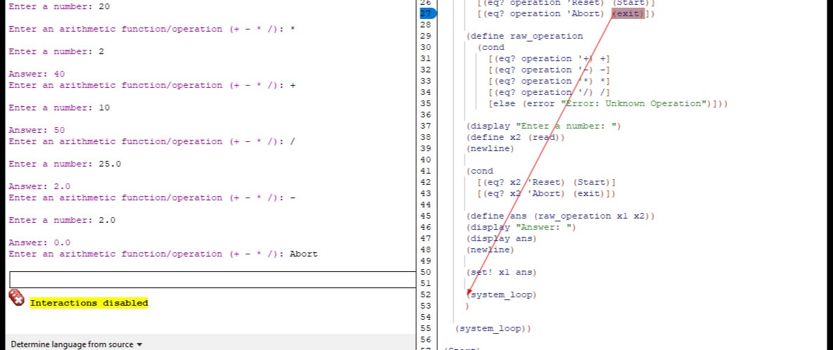

- Reimplement Reverse
Constraints: Scheme’s built in reverse function cannot be used.

https://tinyurl.com/4ud4e677

#lang racket

(define Michael_Kelso
(list "Ashton Kutcher" "February" '7 '1978))

(define Reverse_Michael_Kelso_Info
(list))

;; length limiter
(define rev
(lambda (listObj)
(if (null? listObj)
'()
(append (rev (cdr listObj))
(list (car listObj))))))

(display (rev Michael_Kelso))

;; (define lambda (reverse)
;; if eq? reverse(list))

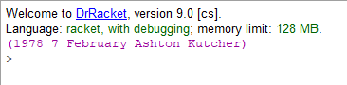

- How many times does the string “e” & “” appear in a list?

https://tinyurl.com/3y4925kj

#lang racket

(define random_strings
(list "e" "" "foo" "bar" "" "fizz" "buzz" "e"))

(display "There are ")

(define appearances 0)

(define string_test
(lambda (str)

(cond
[(string=? str "e") (set! appearances (+ appearances 1))]
[(string=? str "") (set! appearances (+ appearances 1))])))

(define special_appearance
(lambda (listObj)

(if (null? listObj)
(display appearances)

(begin
(string_test (car listObj))
(special_appearance (cdr listObj))))))

(special_appearance random_strings)

(display " special appearances of 'e' & An Empty String!")

